Xihao Zhu xz36

HW2

P1-P4

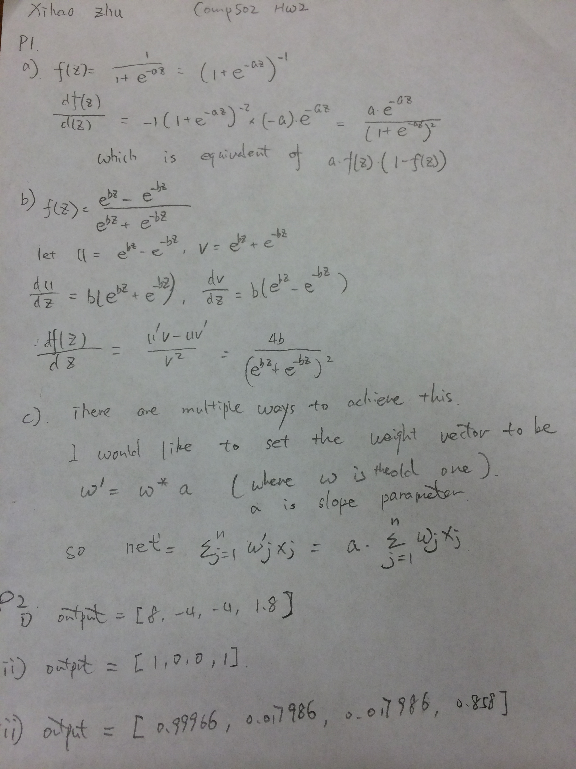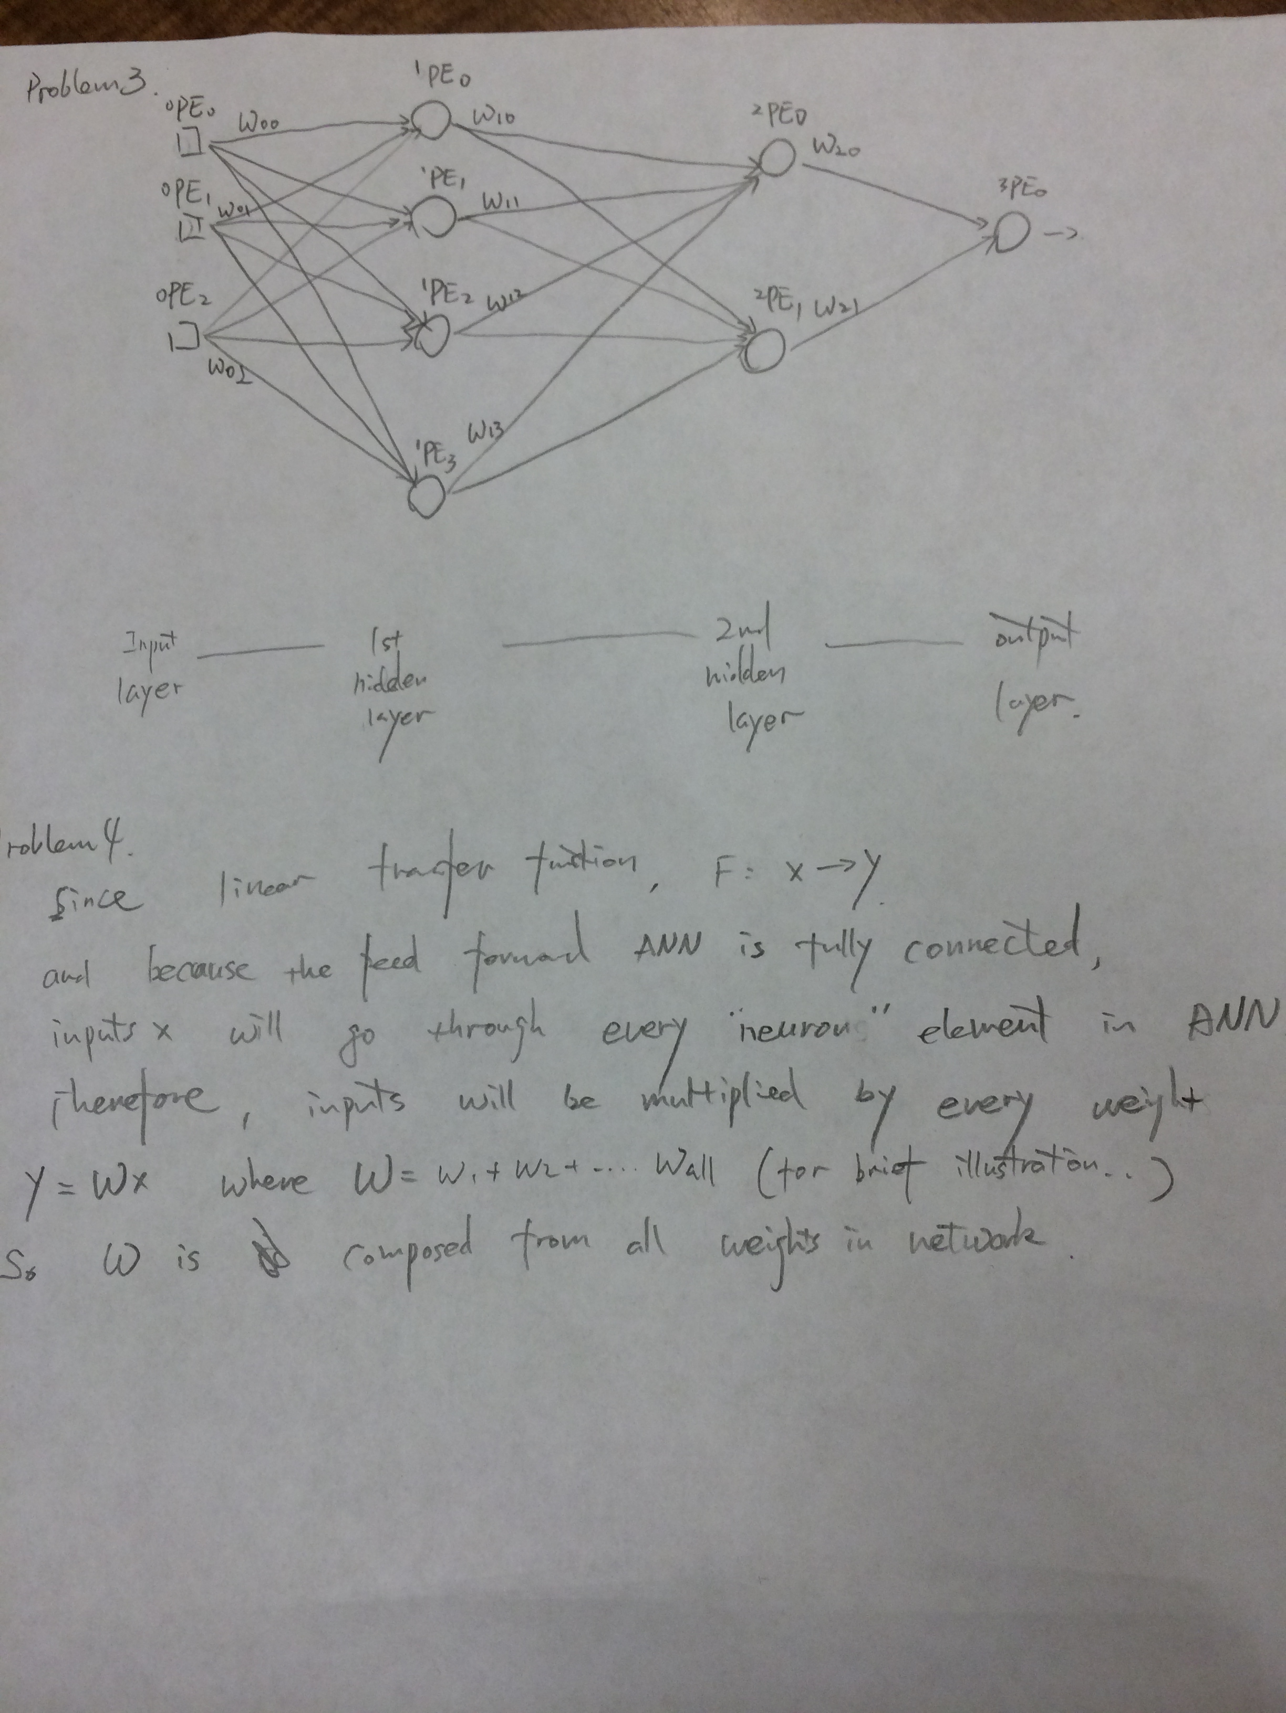

P5.

(a)

I used MM=errcorr(X,Y, 0.005,50,0.5) to get the memory

My X is 144x5 matrix, while Y is 5x5 matrix.

For example, Y [1;0;0;0;0] is ‘E’, Y[0;1;0;0;0] is ‘H’

Percent of mismatched pixels between Thresholded Recalled and Desired Output images:

E: 0%, H: 0%, M: 0%, T: 0%, O: 0% (all: 0%)

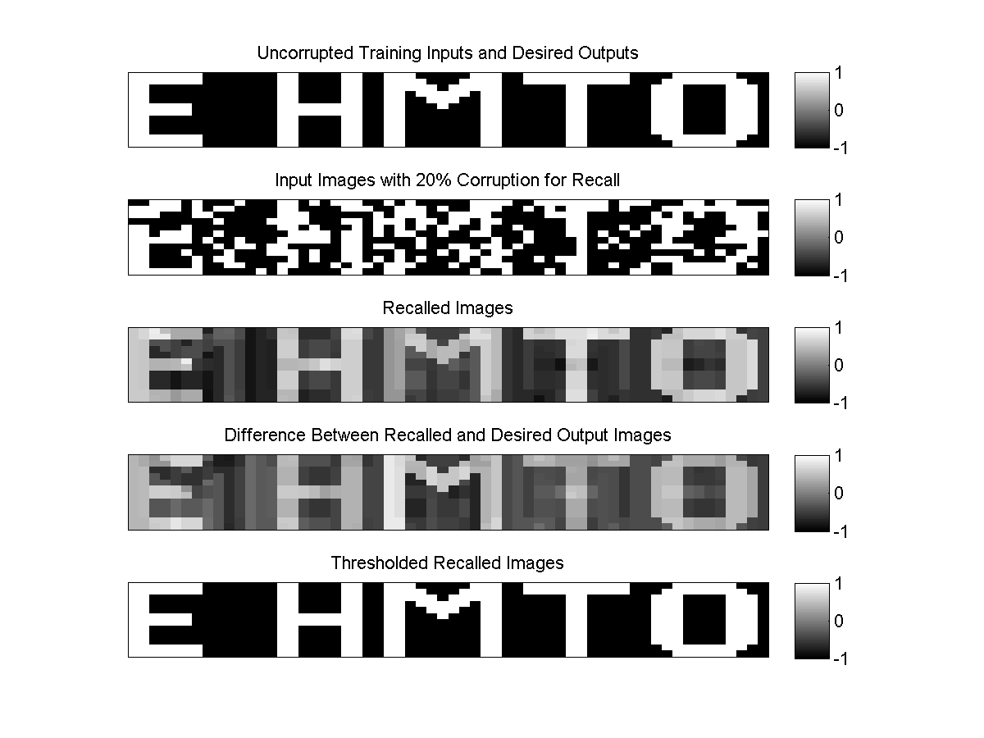

Below is thresholded image output.



the method to get the results are shown as follows:

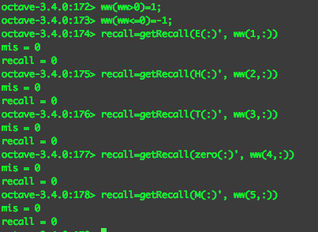

(b)

these are corrupted images. With corrupted rate 20%(29 pixels)

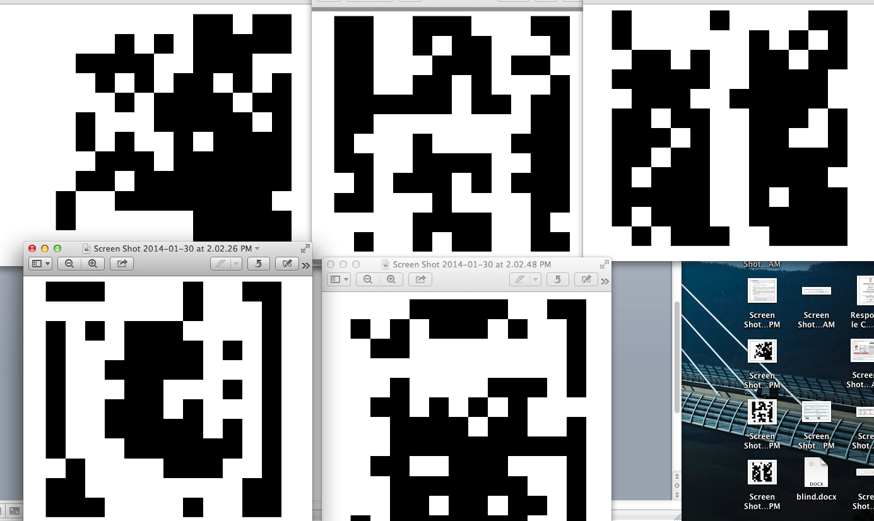

Percent of mismatched pixels between corrupted images and Desired Output images:

E: 25%, H: 25%, M: 25%, T: 25%, O: 25% (all: 25%)

Since we compare 25% corrupted images with good images. So there are 25% incorrect rate.

these are corrupted images. With corrupted rate 25%(36 pixels)

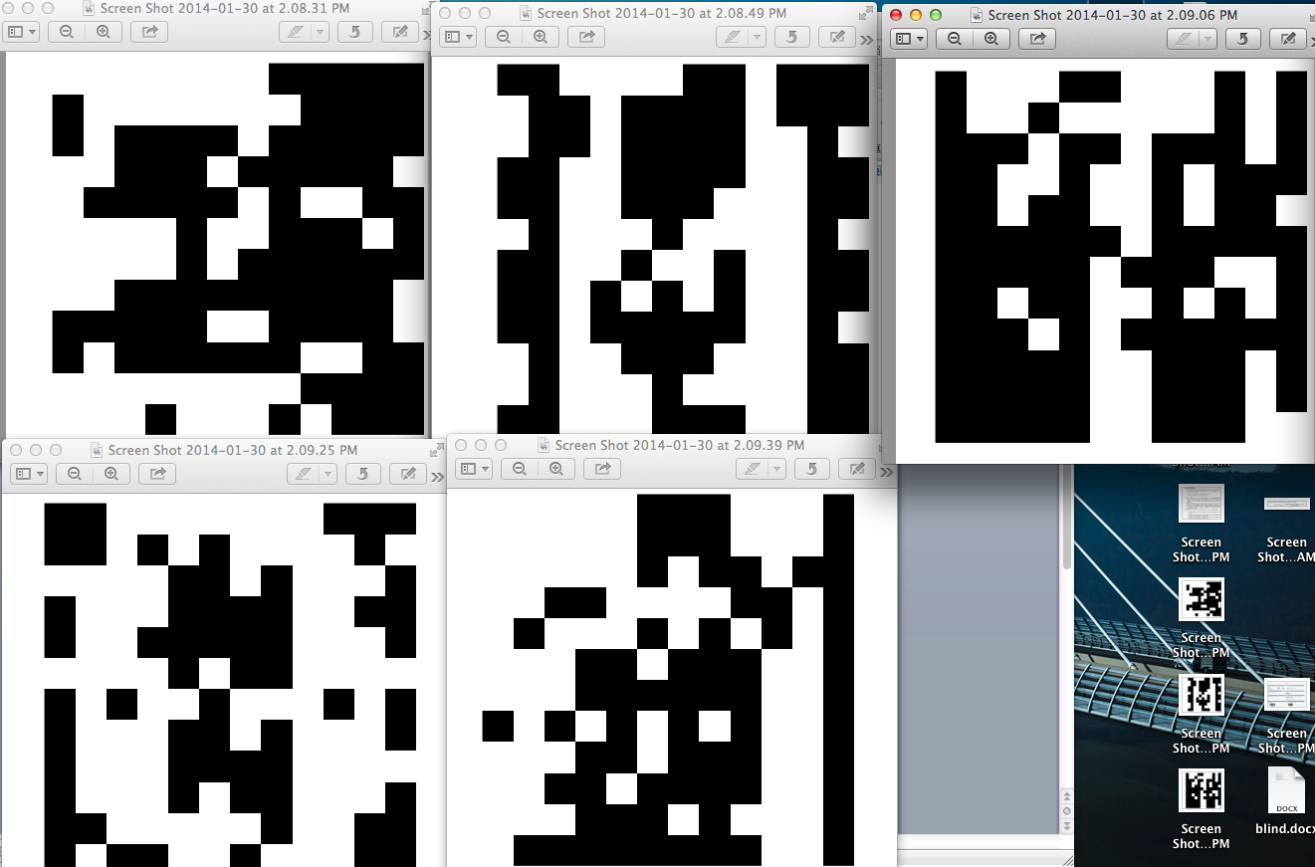

Percent of mismatched pixels between corrupted images and Desired Output images:

E: 36%, H: 36%, M: 36%, T: 36%, O: 36% (all: 36%)

Since we compare 36% corrupted images with good images. So there are 36% incorrect rate.

these are corrupted images. With corrupted rate 50%(72 pixels)

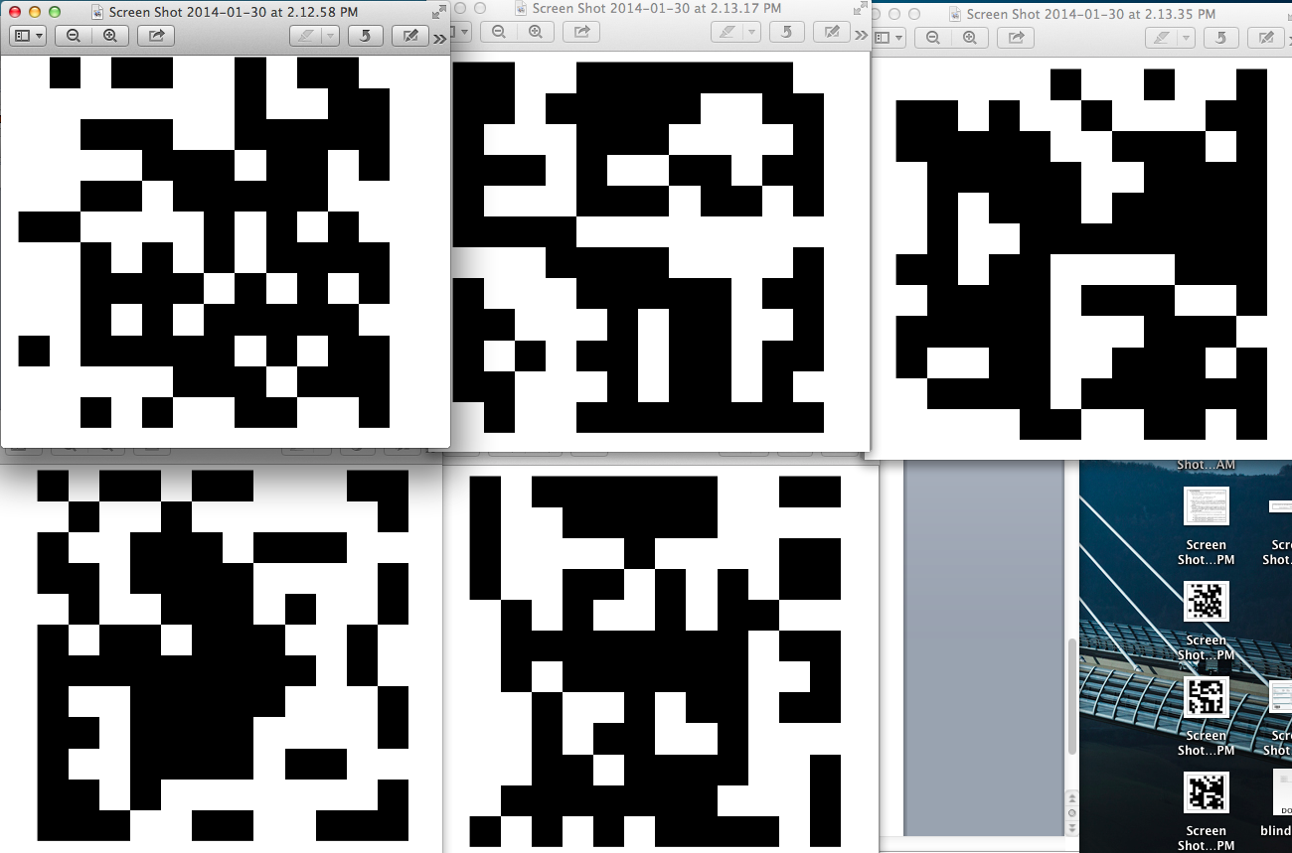

Percent of mismatched pixels between corrupted images and Desired Output images:

E: 50%, H: 50%, M: 50%, T: 50%, O: 50% (all: 50%)

Since we compare 50% corrupted images with good images. So there are 50% incorrect rate.

(c).

20% corrupted data



using MM=errcorr(X,Y,0.01, 100,1)

Percent of mismatched pixels between corrupted images and Desired Output images:

E: 12.3%, H: 19.8%, M: 16.3%, T: 22%, O: 14.2%